

Helmet package yzid quelque http headers to increase secure ( c’est un package must use in each project )



Limit requests contre les attack DOS

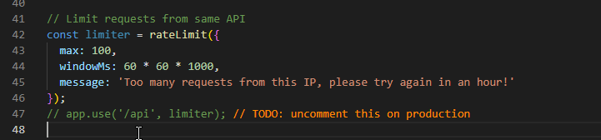

Limitation des package size, aussi pour limite les attack DOS

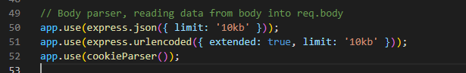

Yagla les script from http body, car kayen liydiro custom text fel http body liyt executa au niveau du mongoDB ou postgresql aya yzido user puis yado access l database wla backend b hadek user

mongoSanitize yvirefe que text li rah f http body is only data not a script



To prevent something like this “email” : { “$gt” : “”}

La ou user rsel json body inside email …. Li email = string

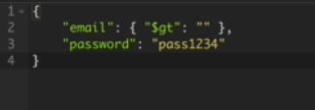

Sanitize untrusted html ( to prevent XSS )



Preventing parameter pollution from http request, like duplication or infinite of parameters

Like



Sort rahi specifie deux fois

Pour regle ce problem ndiro delete l all apar white list ….

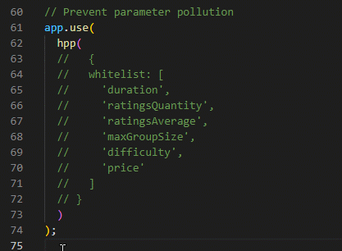

Nzido time and date l each request received prc time and date au niveau de client machi daymen mregel et aussi hacker ykad yarsel request w date and time ymodifih donc on each request received ndirlha time and date from server lirah ytmacha fih nodejs

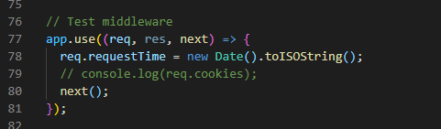

La line 22 difine que ga3 les REST API end point lirahom that la line 22 ydemandiw user ykon authetificated selon JWT ( user is already logged in pour consome les API END POINT that line 22 )

Line 26 = only user with role = admin ou teacher ou student ou parent ykad ytulise GET

Line 26 = only user with role admin ykad ydir post ( add new data )

C’est un script pour faire CRUD l classroom ( create, read, update, delete ) mais avec les permissions

